ACMEv2 Toolbox:

Step by Step:

0. Derive Thresholds from Cirque Outlines

This program derives cirque thresholds based on DEM and cirque polygons (outlines). The cirque threshold is defined as the highest flow accumulation point along the cirque boundary, which usually corresponds to the lowest point along the boundary. The inputs include DEM and cirque outlines (polygons). The output is the derived cirque thresholds. Make sure that the DEM and cirque outlines have the same projected coordinate system (UTM or other projected systems, not the latitudes and longitudes).

Yingkui Li

Department of Geography & Sustainability

University of Tennessee, Knoxville, TN 37996

06/01/2023

Input cirque outlines as a polygon feature layer, feature class, or shapefile.

Input digital elevation model (DEM) as a raster layer or raster dataset.

The derived cirque threshold points as a feature class or shapefile.

1. Derive Size, Shape, and Altitude Metrics

This tool derives the size, shape, and altitude parameters related to each cirque. The size parameters include L (length), W (width), H (height), CS (cirque size), Perimeter, A2D (2D area), and A3D (3D area). The shape parameters include L_W (L/W ratio), L_H (L/H ratio), W_H (W/H ratio), A3D_A2D (A3D/A2D ratio), Circular (circularity), Slope_mean, Aspectmean, Plan_clos (plan closure), and Prof_clos (profile closure). The altitude parameters include Z_min, Z_max, Z_mean, Z_median, Z_mid (middle altitude), Hypsomax, and HI.

This tool includes three inputs: Input Cirque Outlines, Input DEM, and Input Cirque Thresholds, and four outputs: Output Length Features, Output Width Features, Output Mid-Alt Contours, and Output Cirques. Make sure that the DEM, cirque outlines, and cirque thresholds have the same projected coordinate system (UTM or other projected systems, not the latitudes and longitudes).

Input cirque outlines as a polygon feature layer, feature class, or shapefile.

Input digital elevation model (DEM) as a raster layer or raster dataset.

Input cirque thresholds as a point feature layer, feature class, or shapefile.

Output derived cirque length features as a polyline feature class or shapefile.

Output derived cirque width features as a polyline feature class or shapefile.

Output derived cirque mid-alt contour features as a polyline feature class or shapefile.

Output cirques with derived size, shape, and altitude metrics.

Yingkui Li

Department of Geography & Sustainability

University of Tennessee, Knoxville, TN 37996

06/01/2023

2. Derive Axis-related Metrics

This tool derives the axis-related cirque metrics, including Axprofclos, Axhli, Axasp, Axgrad and Axamp, and the axis-related curve-fitting parameters, including L_Exp_A, L_Exp_B, L_Exp_R2, L_Kcurv_C, L_Kcurv_R2, W_Quad_C, and W_Quad_R2.

This tool includes four inputs: Input Cirque Outlines, Input DEM, Input Length Features, and Input Width Features. The derived metrics are directly saved to the attribute table of the input cirque outlines. Make sure that all inputs have the same projected coordinate system (UTM or other projected systems, not the latitudes and longitudes).

Input cirque outlines as a polygon feature layer, feature class, or shapefile.

Input digital elevation model (DEM) as a raster layer or raster dataset.

Input cirque length features as a polyline feature layer, feature class, or shapefile.

Input cirque width features as a polyline feature layer, feature class, or shapefile.

Make sure that all inputs have the same projected coordinate system (UTM or other projected systems, not the latitudes and longitudes).

3. Derive Catchment Metrics

This tool derives the two metrics, Maxabalt and Pctabarea, related to the catchment area of each cirque. This tool includes two inputs: Input Cirque Outlines and Input DEM. The derived metrics are directly saved to the attribute table of the input cirque outlines. Make sure that the DEM and cirque outlines have the same projected coordinate system (UTM or other projected systems, not the latitudes and longitudes).

Input cirque outlines as a polygon feature layer, feature class, or shapefile.

Input digital elevation model (DEM) as a raster layer or raster dataset.

Make sure that the DEM and cirque outlines have the same projected coordinate system (UTM or other projected systems, not the latitudes and longitudes).

Whole Process

Whole Calculations With Auto-derived Thresholds

This tool derives the 37 cirque metrics (size, shape, altitude, axis-related and catchment-related parameters) based on the input cirque outlines and a DEM. First, the cirque threshold points are automatically derived as the highest flow accumulation point along each cirque boundary. Then, these cirque threshold points are used to derive threshold-related cirque metrics. Note that if the users have their own threshold points, use the other tool or step-by-step tools to derive cirque metrics.

This tool includes two inputs: Input Cirque Outlines and Input DEM, and five outputs: Output threshold points, Output Length Features, Output Width Features, Output Mid-Alt Contours, and Output Cirques. Make sure that the input DEM and cirque outlines have the same projected coordinate system (UTM or other projected systems, not the latitudes and longitudes).

Input cirque outlines as a polygon feature layer, feature class, or shapefile.

Input digital elevation model (DEM) as a raster layer or raster dataset.

Output derived cirque threshold points as a feature class or shapefile.

Output derived cirque length features as a polyline feature class or shapefile.

Output derived cirque width features as a polyline feature class or shapefile.

Output derived cirque mid-alt contour features as a polyline feature class or shapefile.

Output cirques with all derived metrics.

Whole Calculations With Specified Thresholds

This tool derives the 37 cirque metrics (size, shape, altitude, axis-related and catchment-related parameters) based on the input cirque outlines, DEM, and cirque threshold points. Note that the user needs to provide the cirque thresholds, which can be derived by manual digitization or step 0 in the step-by-step tools.

This tool includes three inputs: Input Cirque Outlines, Input DEM, and Input threshold points, and four outputs: Output Length Features, Output Width Features, Output Mid-Alt Contours, and Output Cirques. Make sure that all inputs have the same projected coordinate system (UTM or other projected systems, not the latitudes and longitudes).

Input cirque outlines as a polygon feature layer, feature class, or shapefile.

Input digital elevation model (DEM) as a raster layer or raster dataset.

Input cirque threshold points as a feature layer, feature class, or shapefile.

Output derived cirque length features as a polyline feature class or shapefile.

Output derived cirque width features as a polyline feature class or shapefile.

Output derived cirque mid-alt contour features as a polyline feature class or shapefile.

Output cirques with all derived metrics.

Make sure that all inputs have the same projected coordinate system (UTM or other projected systems, not the latitudes and longitudes).

**PalaeoIce 2.0**

Connect OGGM centerlines

This tool connects the modern glacier centerlines derived by the OGGM model. Maussion et al., 2019. used the OGGM model to derived the centerlines of all RGI 6.0 glaciers (https://docs.oggm.org/en/stable/assets.html). Therefore, these centerlines can be used in PalaeoIce. However, the OGGM centerlines from different tributaries within a glacier are not connected. This tool connect the centerlines within a glacier to generate a connected centerline system for PalaeoIce Reconstruction.

#

Author: Yingkui Li

Created: 2022-11-23

Copyright: (c) Yingkui Li 2023

Department of Geography & Sustainability, University of Tennessee

Knoxville, TN 37996, USA

Email: [yli32@utk.edu](mailto:yli32@utk.edu)

Input extant glacier outlines as a polygon feature layer, feature class, or shapefile.

Input OGGM centerlines as a feature layer, feature class, or shapefile.

Input digital elevation model (DEM) as a raster layer or raster dataset.

Input search distance to connect the OGGM centerlines. The default value is 30 m.

Output connected flowlines as a polyline feature class or shapefile.

Remove Overlapping Flowlines

This tool removes the potential overlapping flowlines (one flowline is the identical or a small section of another flowline). The overlapping flowlines may cause the errors in the palaeoice reconstruction.

Input the flowlines with overlapping flowlines as a polyline feature layer, feature class, or shapefile.

Output the cleaned flowlines as a polyline feature class or shapefile.

**Extract Glacier Thickness Data from Farinotti et al. (2019) Global Dataset**

This tool extracts and merges the individual glacier thickness tif files generated by Farinotti et al. (2019): A consensus estimate for the ice thickness distribution of all glaciers on Earth. Nature Geoscience 12, 168–173 and its associated dataset link: <https://www.research-collection.ethz.ch/handle/20.500.11850/315707>. The individual glacier thickness tif file is named based on the RGI ID of each glacier. This tool creates a merged raster file for all input RGI glaciers, so that the data can be used to remove glacier topography from DEM or compared with the simulated ice thickness data by Volta, PalaeoIce, and other glacier reconstruction models.

# Created by: Yingkui Li 2023

Department of Geography & Sustainability, University of Tennessee

Knoxville, TN 37996, USA

Email: [yli32@utk.edu](mailto:yli32@utk.edu)

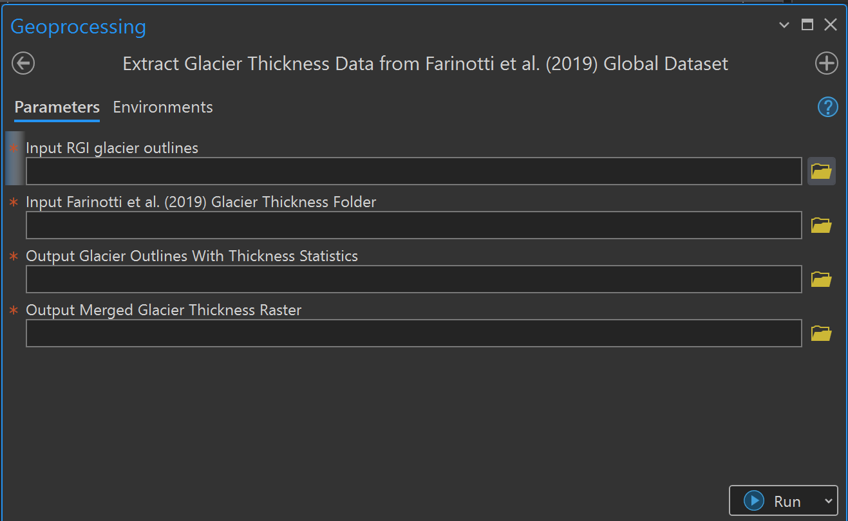

Input RGI glacier outlines as a shapefile or feature class. The glacier outlines should include the RGI ID that can be used to match the ice thickness tif files.

Specify the folder that contains all ice thickness tif files estimated by Farinotti et al. (2019)

Output Glacier outlines as a feature class or shapefile with summarized ice thickness (mean, min, max, std, etc) in the attribute table.

Output merged ice thickness raster for all input RGI glaciers

Yingkui Li

Department of Geography & Sustainability, University of Tennessee

Knoxville, TN 37996, USA

Email: [yli32@utk.edu](mailto:yli32@utk.edu)

**Lake Extraction from DEM**

This tool extracts lakes from a DEM based on a minimum area threshold. The lake in a DEM should have zero slopes within the lake area. Therefore, slope analysis can be used to extract lakes. A minimum area is used to remove the noises.

Input digital elevation model (DEM) as a raster layer or raster dataset.

Specify the minimum lake area in square km. This value will be used to remove extracted smaller polygons.

Output extracted lakes as a polygon feature class or shapefile.

**Remove Lake Topography**

This tool is designed to estimate lake bathymetric topography based on lake outlines and specified depth points (required), contours (optional) or simply a maximum depth in the lake polygon attribute table. Then, the estimated lake thickness is removed from the DEM to generate a bare-earth DEM.

Input digital elevation model (DEM) as a raster layer or raster dataset.

Input lake polygons as a feature layer, feature class, or shapefile.

Input lake depth contours as a feature layer, feature class, or shapefile. This is optional.

Specify the depth field for each contour line. This is associated with the input lake contours.

Input lake depth points as a feature layer, feature class, or shapefile.

Specify the depth field associated with the input depth points.

Output estimated lake thickness raster

Output adjusted DEM after subtracting the lake thickness raster

**Smooth Elevations Along Certain Flowline Sections**

This tool smooths the elevations along the specified flowline section that may be affected by the down-cut of rivers under the ice or after glacier retreat. This tool first uses a buffer of the flowline section to extract the elevations within the buffer boundary lines. Then, interpret the elevation surface within the buffer zone based on the points from the buffer boundary lines. Finally, the DEM is adjusted by replacing the interpreted elevations within the buffer zone.

Input digital elevation model (DEM) as a raster layer or raster dataset.

Input flowline sections that need to be adjusted as a feature layer, feature class, or shapefile.

Specify a buffer distance in meters.

Output adjusted DEM after smoothing the elevations of the flowline sections.

**Palaeo Ice Reconstruction With Palaeoice Outline(s)**

This tool calculates the palaeoglacier thickness (points) along flowlines and produces ice thickness and surface elevation rasters based on the Excel flowline model introduced by Benn and Houlton (2010) and the ArcGIS model, GLaRe, developed by Pellitero et al.(2016). This tool automatically adjusts shear stress and shape factors based on the DEM and the palaeoglacier outline(s). Because a large glacier may include many tributaries, this updated tool derives the shear stress value for each flowline of the reconstructed glacier. The optimization of the shear stress is implemented by an iteration process: 1) a default shear stress value is first used to derive the ice thickness points along the flowline(s); 2) the ice thickness points are then compared with the elevations extracted from the input palaeoglacier outlines; and 3) the shear stress is then optimized based on best-fit between these two sets of elevations.

This tool automatically adjusts the shape factors based on the ice cross sections along the flowlines. Two options are available for the shape factor calculation: one is based on the cross-section area, ice-contact perimeter, and ice thickness; the other is based on the fit of the polynomial function introduced by Li et al (2012). The updated tool also provides the six methods to interpret the palaeoice surface elevations: TopoToRaster, Kriging, IDW, Trend, NaturalNeighbor, and Spine. The default method is TopoToRaster, which generates a hydrological corrected ice surface raster. The ice thickness raster is then derived by subtracting the ice surface raster and the bare-ground DEM.

Created by Yingkui Li, Department of Geography and Sustainability, University of Tennessee, Knoxville, TN 37996, USA. Email: [yli32@utk.edu](mailto:yli32@utk.edu)

Specify the ice surface interpolation method. Six methods are available for the interpolation: TopoToRaster, Kriging, IDW, Trend, NaturalNeighbor, and Spine. The default method is TopoToRaster, which generates a hydrological corrected ice surface raster.

Yingkui Li

Department of Geography & Sustainability, University of Tennessee

Knoxville, TN 37996, USA

Email: [yli32@utk.edu](mailto:yli32@utk.edu)

**Palaeo Ice Reconstruction Without Palaeoice Outline(s)**

This tool calculates the palaeoglacier thickness (points) along flowlines and produces the reconstructed palaeoglacier outlines (polygons), and the ice thickness and surface elevation rasters based on the Excel flowline model introduced by Benn and Houlton (2010) and the ArcGIS model, GLaRe, developed by Pellitero et al.(2016). This tool automatically adjusts shear stress and shape factors based on the DEM and the optional target geomorphic features (usually linear features, but can also be point and polygon features), such as trimlines and vegetation breaks, to constrain the palaeoice boundaries. Because a large glacier may include many tributaries, this updated tool derives the shear stress value for each flowline of the reconstructed glacier. The optimization of the shear stress is implemented by an iteration process: 1) a default shear stress value is first used to derive the ice thickness points along the flowline(s) and the ice thickness points is used to interpolate the palaeoice surface elevation; 2) then, the shear stress is updated based on the derived ice elevation distribution and compared to the previous shear stress value. The above iteration is stopped until the shear stress reaches a stable value. If target geomorphic features are provided, the shear stress is adjusted based on the best fit of the calculated ice thickness elevations and target elevations and the minimum distance offset between the reconstructed ice boundary and the target geomorphic features.

This tool automatically adjusts the shape factors based on the ice cross sections along the flowlines. Two options are available for the shape factor calculation: one is based on the cross-section area, ice-contact perimeter, and ice thickness; the other is based on the fit of the polynomial function introduced by Li et al (2012). The updated tool also provides the six methods to interpret the palaeoice surface elevations: TopoToRaster, Kriging, IDW, Trend, NaturalNeighbor, and Spine. The default method is TopoToRaster, which generates a hydrological corrected ice surface raster. The ice thickness raster is then derived by subtracting the ice surface raster and the bare-ground DEM.

Created by Yingkui Li, Department of Geography and Sustainability, University of Tennessee, Knoxville, TN 37996, USA. Email: [yli32@utk.edu](mailto:yli32@utk.edu)

Specify the ice surface interpolation method. Six methods are available for the interpolation: TopoToRaster, Kriging, IDW, Trend, NaturalNeighbor, and Spine. The default method is TopoToRaster, which generates a hydrological corrected ice surface raster.

